**An**

**Industrial Training Report on**

**Hardware & Networks**

**AT**

**PRIVI ORGANICS PVT. LTD. – MAHAD**

**Submitted as a partial fulfilment of**

**DIPLOMA IN INFORMATION TECHNOLOGY**

**Submitted By**

**Mr. Jadhav Manish Shashikant (2201933)**

**PRN No. - 2030408246006**

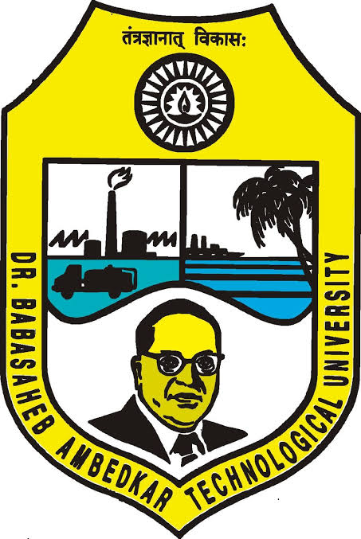

**DEPARTMENT OF INFORMATION TECHNOLOGY**

**DR. BABASAHEB AMBEDKAR TECHNOLOGICAL UNIVERSITY’S**

**INSTITUTE OF PETROCHEMICAL ENGINEERING**

Lonere, Tal. Mangaon, Dist. Raigad, Maharashtra-402103

**Academic Year: 2022-2023**

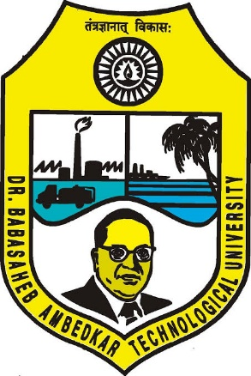

**DEPARTMENT OF INFORMATION TECHNOLOGY**

**INSTITUTE OF PETROCHEMICAL ENGINEERING**

Lonere, Tal. Mangaon, Dist. Raigad, Maharashtra-402103

**CERTIFICATE**

This is to certify that the Industrial Training report entitled

**Hardware & Networks**

Submitted by

**Mr. Jadhav Manish Shashikant (2201933)**

**PRN No. - 2030408246006**

is a bonafide work of student of final year Diploma in Information Technology submitted in partial fulfilment for the award of Diploma in Information Technology as prescribed by Dr. Babasaheb Ambedkar Technological University’s, Institute of Petrochemical Engineering, Lonere during the academic year 2022-2023.

**Prof. K. R. Korpe Prof. S. M. Gaikwad**

**Industrial Training Coordinator Head of Department**

**Acknowledgement**

The successful completion of this training course conducted by Privi Organics Pvt. Ltd., gained me a great learning experience. At the same time, it also gave me confidence to work in professional career development. I feel the experience gained during this training will definitely lead me to gain the bright future prospect in the future. I would like to extend my sincere thanks to Mr. Raju Pawar Sir who guided me over whole training. I express my profound thanks to Mr. Karan Korpe Sir, Industrial Training Guider.

Thank you!

**Mr. Jadhav Manish Shashikant**

Department of Information Technology

Dr. Babasaheb Ambedkar Technological University’s

Institute of Petrochemical Engineering, Lonere

**ABSTRACT**

Industrial training is on of the requirements to be fulfilled in order to obtain a diploma. Each student in these fields needs to do industrial training in audit form. The student is compulsory to undergo an industrial training for duration of 1 month which consists of 4 weeks after completing their second year.

The objective of these industrial training is to expose student to actual working environment. Besides to cultivates team work, spirit and familiarize with colleagues. By undergoing the industrial training; student will create a trustworthy responsible person. Besides that, objective of Industrial Training to build self confidence among students and let them know the technical knowledge and professionalism.

**INDEX**

|  |  |  |
| --- | --- | --- |
| **Serial no.** | **Contents** | **Page no.** |
| **1.** | **Computer Hardware** | **06-09** |
| **2.** | **RAM and its Types** | **10-13** |
| **3.** | **Types of Hard Drives** | **14-15** |
| **4.** | **Displaying Ports** | **16-18** |
| **5.** | **Processor in a PC** | **19-20** |
| **6.** | **Windows and its Versions** | **21-27** |
| **7.** | **Computer Networks** | **28-29** |
| **8.** | **RJ45 & RJ11 Connectors** | **30** |
| **9.** | **IP Address And its Classes** | **31-33** |
| **10.** | **Network Topologies** | **34-37** |
| **11.** | **Report Submission** | **38** |

**1. Computer Hardware**

Computer Hardware is the physical part of computer, as distinguished from the computer software that executes or runs on the hardware. The hardware of computer is infrequently changed, while software and data are modified frequently.

**What’s in the Computer hardware?**

**1.CPU:-**

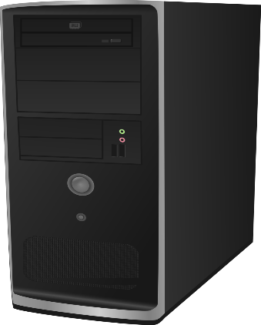

CPU stands for Central Processing Unit. CPU controls computer processes and communicates with other components of personnel computer. If computer is experiencing issues, technicians may start by checking the fan and cleaning out the dust or by verifying the power supply cables are connected. CPU will not function properly unless it receives a signal from power supply.

**2.Motherboard:-**

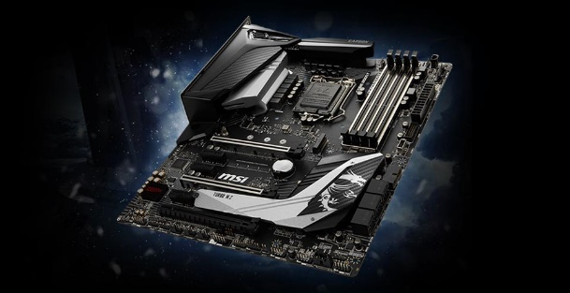

The motherboard provides the structure for all other components and connects them, while also providing a way to distribute power, deliver information. The motherboard includes many components such as: Central Processing Unit(CPU), Random Access Memory(RAM), etc.

**3.Random Access Memory:-**

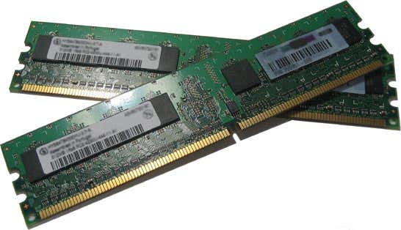

Random access memory (RAM) is fast-access memory, where data lives temporarily until the computer is power-down. RAM attaches directly to the motherboard, and is used to store programs that are currently running. RAM is a set of integrated circuits that allow the stored data to be accessed in any order.

**4.VGA PORT:-**

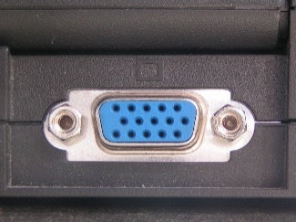

Video Graphics Array(VGA) Port is a video input that is primarily used on PC monitor.

**5.Power Supply:-**

It provides electricity to all the components of computer system. It’s a power card connected from back of PC into electricity socket.

**6.Cooling Fan:-**

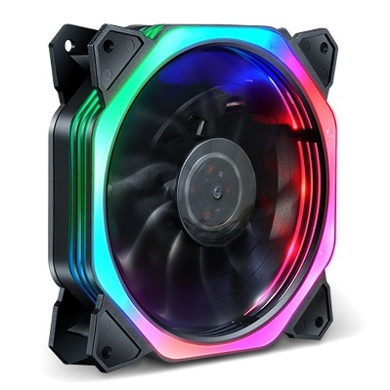

A computer fan is any fan inside, or attached to, a computer case used for active cooling. Fans are used to draw cooler air into the case from the outside, expel warm air from inside and move air across a heat sink to cool a particular component.

**7.Hard Drive:-**

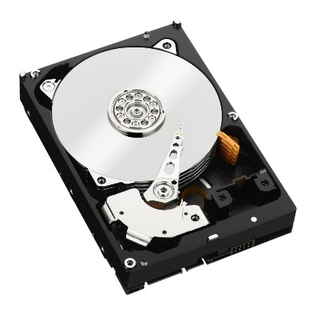

A computer hard drive (or a hard disk or HDD) is one kind of technology that stores the operating system, applications, and data files such a documents, pictures and music that your computer uses.

**8. Microprocessor:-**

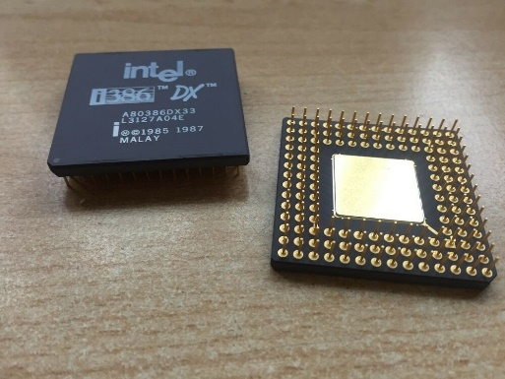

Microprocessor is a controlling unit of a micro-computer, fabricated on a small chip capable of performing ALU (Arithmetic Logical Unit) operations and communicating with the other devices connected to it. In short, it gives commands to other components of computer to perform a specific task.

**9.SMPS:-**

A switched-mode power supply(SMPS) is an electronic circuit that converts power supply using switching devices that are turned on or off at high frequencies.

**10. Expansion Slots:-**

It is a socket on motherboard that is used to insert an expansion card which provides additional features to computer such as video, sound, advanced graphics, Ethernet, memory, etc.

**11.Printer:-**

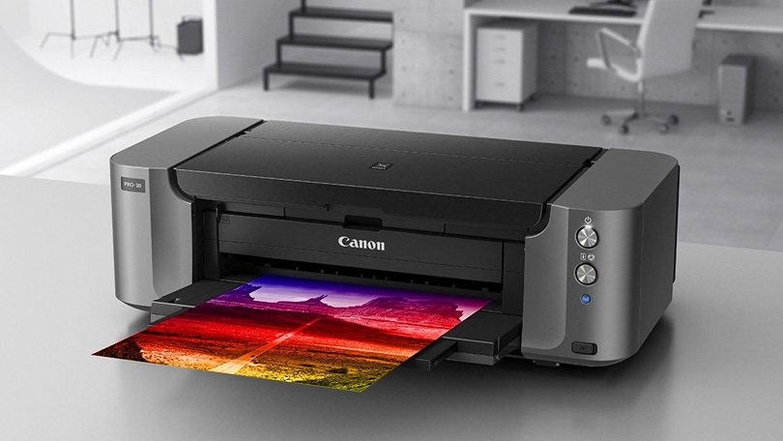

This is a machine that produces copies of text or images on paper using ink. Popular printers include laser or inkjet and computer technicians may be skilled in troubleshooting issues across multiple boards and varieties.

**12.PCI Slots:-**

It is built in slot on device which allows for attachment of various hardware components such as network cards, sound cards, disk controllers and other peripherals.

**2. RAM and its Types**

**What is RAM?**

Random access memory (RAM) is fast-access memory, where data lives temporarily until the computer is power-down. RAM attaches directly to the motherboard, and is used to store programs that are currently running. RAM is a set of integrated circuits that allow the stored data to be accessed in any order.

**TYPES OF RAM:-**

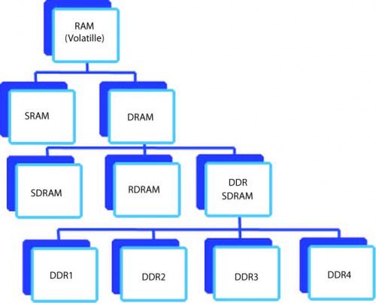

**1.SRAM:-**

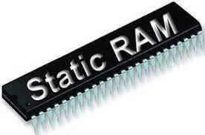

The SRAM memories consists of circuits capable of retaining stored information as long as power supply is applied. It is used to build cache memory. There is no need to refresh SRAM simultaneously.

There are two types of SRAM:-

**a)Non-Volatile SRAM(nVSRAM):-**

It is capable to store all information even if the power supply gets turned off.

**b)Pseudo SRAM:-**

Pseudo SRAM uses self-refresh circuit but it is slow speed Static RAM.

**2.DRAM:-**

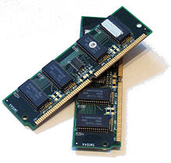

­­­­Stores binary information in the form of electric charges applied to capacitors. Stored information in DRAM tends to loose over a period of time and thus the DRAM must recharged to retained the usage. Process of recharging DRAM is called as DRAM refresh.

There are three types of DRAM:-

**1.SDRAM:-**

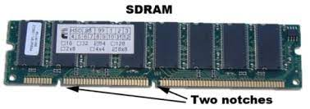

SDRAM stands for Synchronous DRAM. RAM chips access speed is directly synchronized with CPUs clock speed. Memory controller exactly knows exact cycle when requested data will be ready.

**2.RDRAM:-**

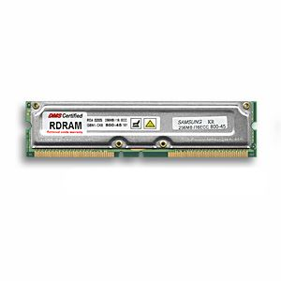

RDRAM stands for Rambus DRAM. It provides high data transfer rate. It uses various speedup mechanisms. The Rambus data bus is 8 or 9 bits.

**3.DDR SDRAM:-**

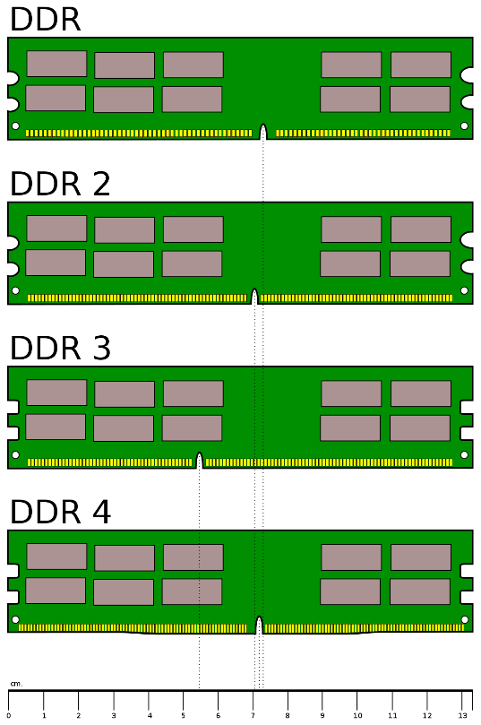

DDR SDRAM stan for Double-Data-Rate SDRAM. It is the faster version of SDRAM. It performs operations on both edges of clock signals.

1. DDR2 SDRAM:-

It is an evolutionary upgrade to DDR SDRAM. It is faster as it can run at higher clock speeds. It runs at lower voltage with more pins, which prevents backward compatibility. It has total of 240 pins.

1. DDR3 SDRAM:-

It improves performance over DDR2 SDRAM through advanced signal processing, greater memory compatibility, lower power consumption and higher standard clock speed. It has same number of pins as DDR2 SDRAM.

1. DDR4 SDRAM:-

It transfer data faster than other DDR SDRAM’s. It is even more advanced by signal processing, even lower power consumption, etc. It has total of 288 pins.

**Difference between SRAM and DRAM is as follows:**

|  |  |
| --- | --- |
| **SRAM** | **DRAM** |
| It is long life memory. | Short data lifetime. |
| No need to refresh. | Needs to refresh continuously. |
| It is faster than DRAM. | It is slower than SRAM. |
| It is used for cache memory. | It is used as main memory. |
| It is large in size. | It is small in size. |
| It has high power consumption. | It has low power consumption. |

**3. Types of Hard Drives**

**What are Hard Drives?**

A computer hard drive (or a hard disk or HDD) is one kind of technology that stores the operating system, applications, and data files such a documents, pictures and music that your computer uses.

**Types of Hard Drives:-**

**1.HDD:-**

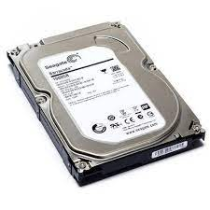

HDD stands for Hard Disk Drive. HDD uses one or more rotating discs covered with thin layer of magnetic material. Data is stored in this thin film. The data stored in HDD is stored when the computer is turned off. A hard disk drive operates at speed of 7200 rpm(rotations per minute).

**2.SSD:-**

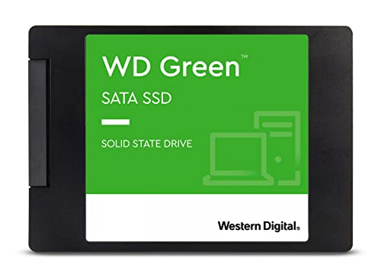

SSD stands for Solid State Drive. It has no moving mechanical part. It uses flash memory like kind found in USB flash drives. Data is stored in electrically instead of magnetically.

**3.PATA:-**

PATA stands for Parallel Advanced Technology Attachment. It is made of mechanical moving parts. It is based on parallel signalling technology that transmits multiple bits of data simultaneously. The data transfer speed is 133mb/s.

**4.SATA:-**

SATA stands for Serial Advanced Technology Attachment. SATA has supressed PATA hard drives in size, pricing, and power consumption. It is based on serial signalling technology that transfers one data bit at a time. Data transfer speed is higher than PATA hard drives i.e. 150-300 mb/s.

**5.SCSI:-**

SCSI stands out for Small Computer System Interface. It upgrades PATA and SATA for speed, storage, etc. It allows connection with peripheral devices such as printers. Its data transmission speed is 320 mb/s.

**4. Display Ports**

Display port is an license free and provides a stable and robust audio/video link, etc. It has high resolutions, faster refresh rates and deeper color depths.

**Types of Display Ports:-**

**1.HDMI Port:-**

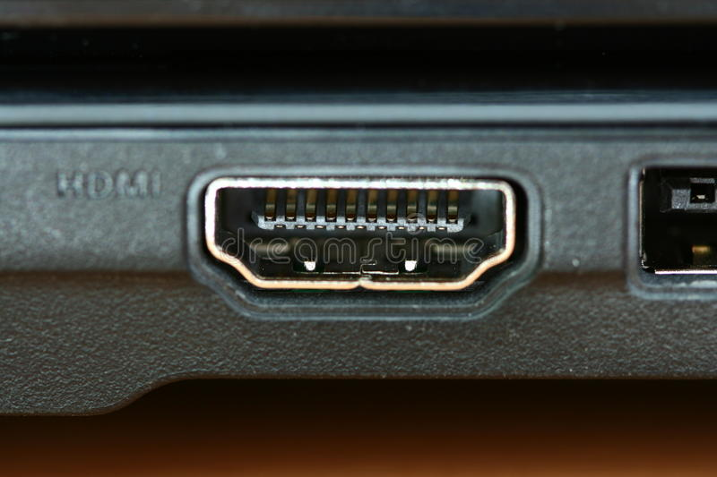

It stands for High Definition Multimedia Interface. It allows you to connect your device to an external display with high definition picture and sound. There are four types of active HDMI cables:-

a)HDMI Standard:- Used for resolution up to 1080p.

b)HDMI High Speed:- Used for 4k resolutions.

c)HDMI Premium High Speed:- Used for HDR-enabled devices.

d)HDMI Ultra High Speed:- Used for devices which includes uncompressed 8k display.

**2.Display Port(DP):-**

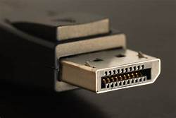

Display Port is an upgrade to HDMI Port. It allows you to connect an external display. It is reserved for high-end mostly used for gaming and video editing. There are three types of DP cables:-

a)Display Port 1.2:- Used for 4k video at 60Hz refresh rate.

b)Display Port 1.3:- Used for 8k video at 30Hz refresh rate.

c)Display Port 1.4:- Used for 8k video at 60Hz refresh rate.

**3.VGA Port:-**

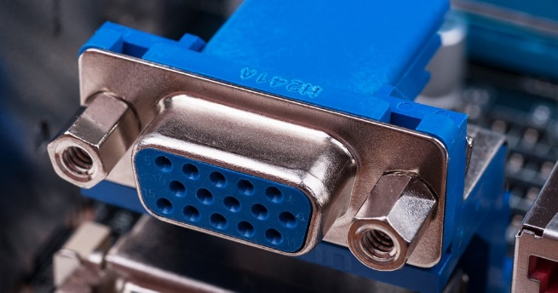

VGA Port stands for Video Graphics Array Port. It allows connection to many Television(TV) and monitors. It is useful for playing certain older video game consoles. It consists of 15 pin connector that features 3 rows of 5 pins.

**5. USB Port A:-**

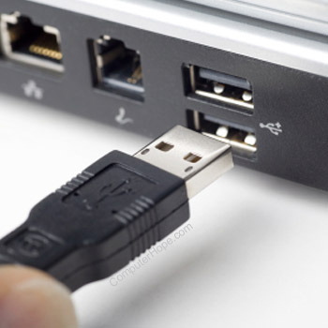

This is a standard USB port which allows connection, communication, and power supply to many types of devices such as keyboard, mic, external devices, etc.

**6. USB Port B:-**

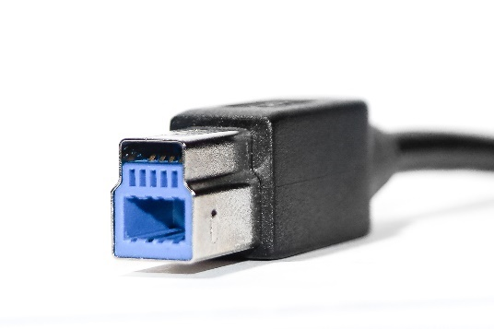

This port is for other end of many USB cables. It is designed to allow only USB port to provide power, preventing electrical overloads that may damage devices.

**5.Processor in a PC**

**What is Processor?**

The processor also known as CPU is a piece of hardware. It is often referred to as the “Brain of a PC” because all the computations and processing are carried out directly or indirectly by the processor containing millions of transistors. It is a single chip that is capable of processing data.

**Types of Processors:-**

**1.4004 (1971):-**

**2.8080 (1974):-**

It was invented without binary compatibility.

**3.8085 (1976):-**

It was 8 bit microprocessor. It was invented with binary compatibility. It had 16 bits address bus and 8 bits data bus.

**4.8086 (1978):-**

It was first ever produced microprocessor with 16-bits. It had 16 bits data bus, 20 bits external bus, and 64k I/O ports.

**5.8088 (1979):-**

It was similar to the 8086 microprocessor but 8088 microprocessor came with reduced external bus width size from 16 bits to 8 bits.

**6.80286 (1982):-**

It was 16 bits processor which came with the memory management.

**7.Intel Pentium (1993 to 1999):-**

It was designed for entry-level PCs and other devices .

**8.Intel Core 2 (2006 to 2011):-**

It was first ever produced microprocessor with 64 bits dual core processor.

**9.Intel Core i3 (2010 – till date):-**

It was affordable and gives nice performance. They aren’t used/are not best for multitasking or challenging tasks like video-editing.

**10.Intel Core i5 (2009 – till date):-**

It was intended to be used by mainstream users. It can perform lots of tasks at once. It can be used for video-editing. It costs lesser than i7 processor but there performance is not that so far.

**11.Intel Core i7 (2008 – till date):-**

It was upgraded version of i5 processor. It had extra performance to make that tough tasks bit easier.

**12.Intel Core i9 (2017 – till date):-**

It is mostly used on specialist computers working on extremely challenging tasks, like editing large videos.

**6.Windows and its Versions**

Windows is a graphical Operating System(OS) which was developed by the Microsoft. It allows to view and store files, run software, play games, watch videos, and provides way to connect to internet.

**Different Versions of Windows:-**

**1.Windows 1.0:-**

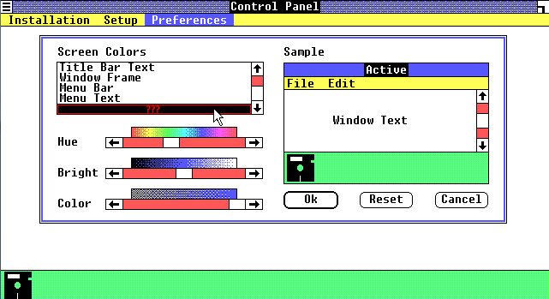

It was the first ever version of Windows. It was first effort to produce graphical user interface in 16-bits.

**2.Windows 2.0:-**

It was the second version of Windows. It was also introduced as Windows 386. It gave new way to maximize and minimize window instead of zooming.

**4.Windows 3.0:-**

It is the first window that needed hard drive. It supported 256 colors that made display interface more colorful and advanced.

**5.Windows**  **3.1:-**

The development code name of this version was Sparta. Minesweeper was used for the first time in this version.

**6.Windows 95:-**

It was named as Windows 95 as it was launched in 1995. It introduced Start button and start menu feature for first time.

**9.Windows CE:-**

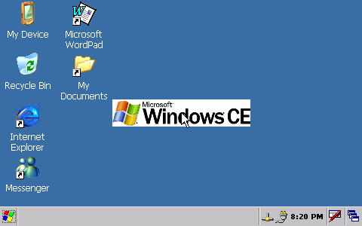

**10. Windows 98:-**

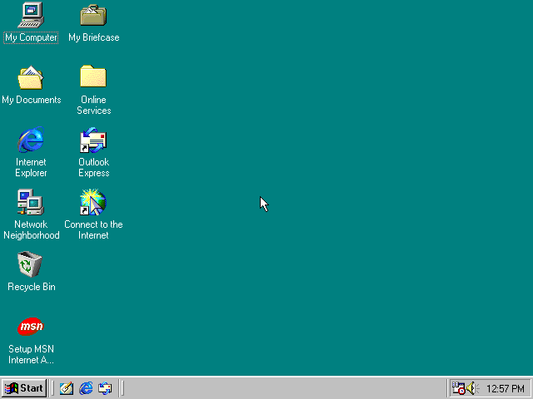

It was named as Windows 98 as it was launched in 1998. It brought address bar and back/forward navigation buttons in Windows Explorer.

**11.Windows ME:-**

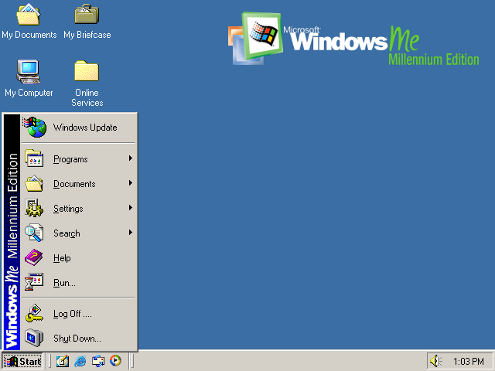

Windows ME stands for Millenium Edition. Internet Explorer 6, Windows Movie Maker, Windows Media Player 7 were used for first time.

**12.Windows 2000:-**

It was introduced in year 2000 and named as per the year. It was first OS that supported hibernation.

**13.Windows XP:-**

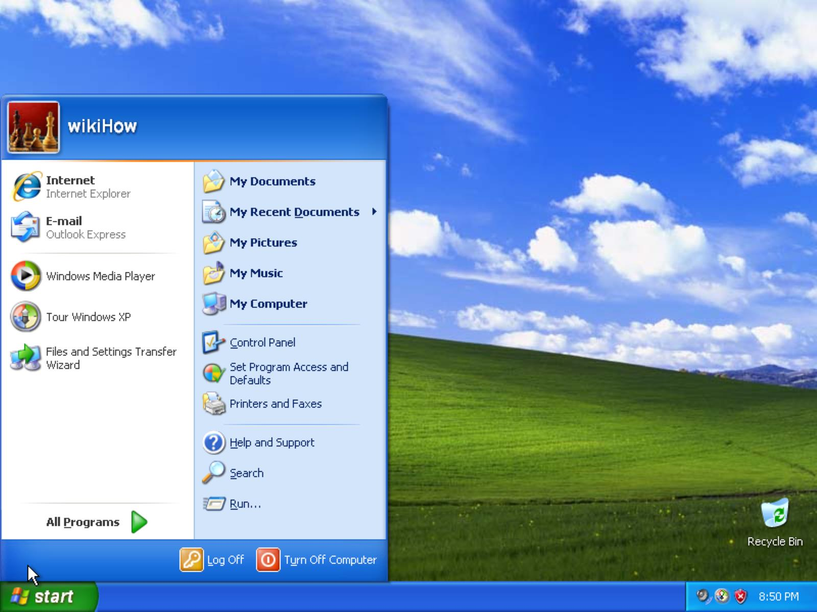

It is considered to be the best version of Windows. Start button and taskbar were replaced by including green start button and blue taskbar.

**14.Windows Vista:-**

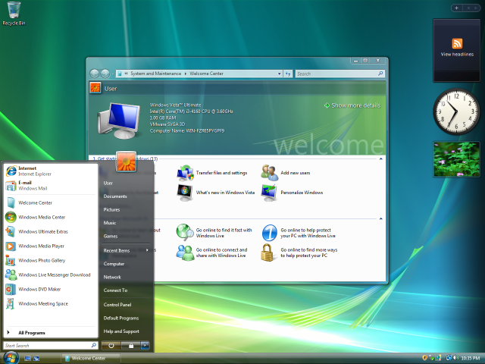

It brought better look and feel user interface. It included transparent elements, security and search. It included Windows Defender, an anti-spyware program.

**15.Windows 7:-**

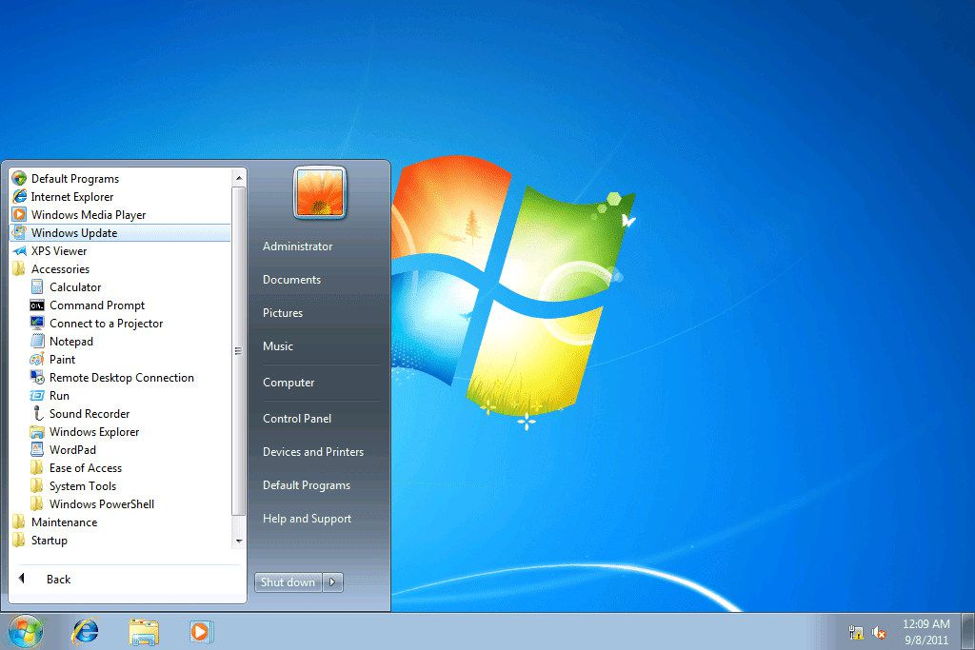

It was introduced to overcome all the problems on Vista. It is more stable, faster, and easy to use.

**16.Windows 8:-**

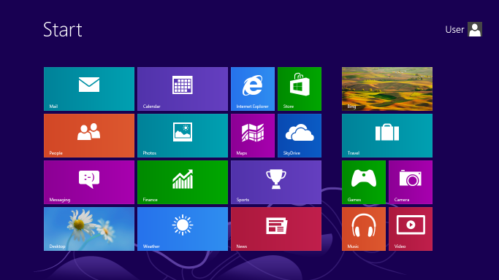

It is the fast OS, and supported USB 3.0 devices, Web Store. Full screen mode was run for the first time.

**17.Windows 8.1:-**

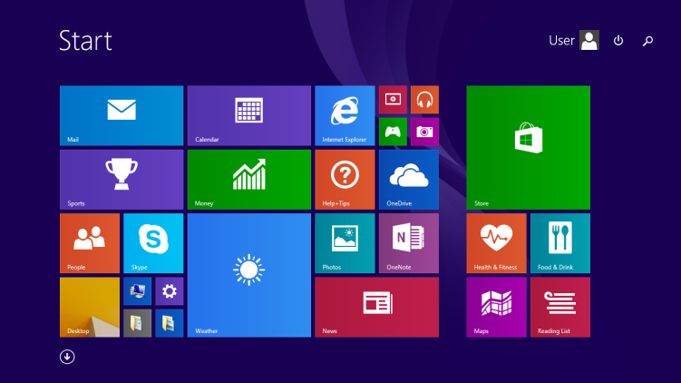

It relaunched Start button. It was able to display Start screen from desktop view. It provided a way to select boot directly into desktop.

**18.Windows 10:-**

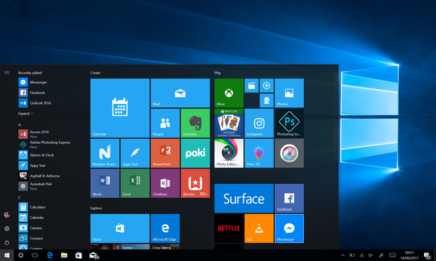

It allowed switching between keyboard and mouse mode and tablet mode.

**19.Windows 11:-**

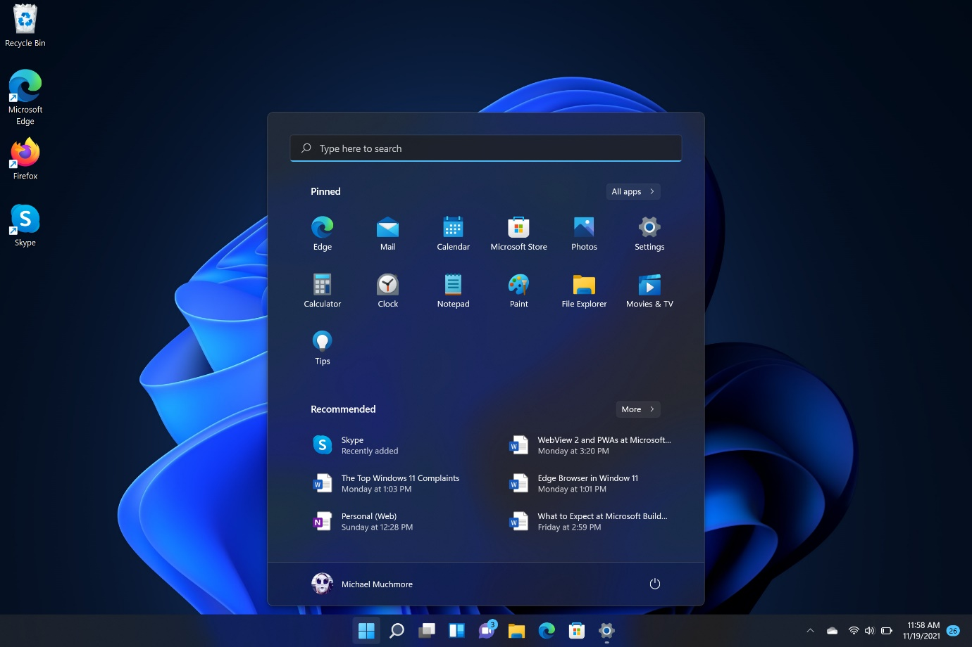

Start button and start menu is placed in centre of the desktop. Start menu is smaller as compared to Windows 10. It allows to install and operate some android applications on Desktop.

**7.Computer Networks**

Group of networks linked to each other that enables computer to communicate with another computer and share their resources, data and applications.

**Types of Computer Networks:-**

**1.LAN:-**

LAN stands for Local Area Network. It is connected to each other in small area. It is used for connecting two or more personal computers through a communication. It ranges up to 100 meters.

**2.PAN:-**

PAN stands for Personal Area Network. It is arranged within individual persons for connecting computer devices such as Personal Hotspot, Bluetooth, etc. It ranges up to 10 meters.

**3.MAN:-**

MAN stands for Metropolitan Area Network. It covers a particular geographic area by interconnecting different LAN to form larger network. It ranges up to 50 kilometers.

**4.WAN:-**

WAN stands for Wide Area Network. It extends over large geographic area such as states or countries. Internet is biggest WAN in the world. It ranges from 100 to 1000 kilometers.

**5.SAN:-**

SAN stands for System Area Network. It provides high performance, connection oriented network that can link a cluster of computers. It delivers high bandwidth.

**6.EPN:-**

EPN stands for Enterprise Area Network. It is built by businesses by connecting all the computers and devices across all departments for purpose of data exchange.

**7.VPN:-**

VPN stands for Virtual Private Network. It provides users local networks security while accessing public internet. We can access VPN servers through client software installed in their Desktop.

**8.HAN:-**

HAN stands for Home Area Network. It is used to interconnect more than a computer with other peripheral devices, a network should be established similar to LAN within that home. It ranges up to 100 meters.

**9.WLAN:-**

WLAN stands for Wireless Local Area Network. It acts like LAN but make use of wireless network technology like Wi-Fi.

**10.CAN:-**

CAN stands for Campus Area Network. It is bigger than LAN but smaller than MAN. It is used in places like a school or college. It ranges from 1km-5km.

**8.RJ45 & RJ11 Connectors**

**1.RJ45 Connector:-**

RJ45 (Register Jack - 45)is a type of connector commonly used for Ethernet networking. Since, Ethernet cables has RJ45 connector at both ends, Ethernet Cables are sometimes called as RJ45 Cables.

**2.RJ11 Connector:-**

RJ11 (Register Jack – 11) is used as connector for plugging a telephone into the wall and handset into telephone.

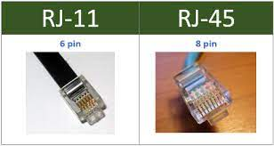

**Difference between RJ45 and RJ11:-**

|  |  |
| --- | --- |
| **RJ45** | **RJ11** |
| It is used in networking for connecting to the internet. | It is cable connector that is used in telephone sets. |
| It is large in size. | It is small in size. |
| It is Square shaped. | It is Rectangular in shape. |
| It provides 24 Mbps bandwidth. | It provides 10 Gbps bandwidth. |

**9.IP Address and its Classes**

**What is IP Address?**

IP stands for ‘Internet Protocol’, part of Transmission Control Protocol/Internet Protocol (TCP/IP). IP is the set of rules governing the format of data sent via the internet or local network. An IP address is a unique address that identifies on the internet or a local network.

IP addresses are typically in the same format as a 32-bit number, as four decimal numbers each with a range of 0 to 255, separated by dots-each set of three numbers is called octet. This format used by IPv4 0.0.0.0 to 255.255.255.255. IPv6 is 128 bits, with eight group of four hexadecimal digits all separated by colon(:).

**IP address Classes:-**

32 bits IP address is divided into five sub-classes:- a, b, c, d, e. Each of these classes has valid range of Ip addresses. Class D and E are reserved for multitasking and experimental purposes. IP address is divides into two parts:

a)Network ID. b)Host ID.

**1)Class A:-**

IP address belonging to class A are assigned that contain a large number of hosts.

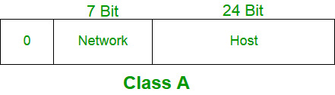

Network ID = 8 bits.

Host ID = 24 bits.

High order bit = 0.

**2)Class B:-**

IP address belonging to class B are assigned to networks that ranges from medium-sized to large-sized network.

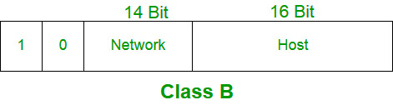

Network ID = 16 bits.

Host ID = 16 bits.

High order bit = 10.

**3)Class C:-**

IP address belonging to class A are assigned for small sized networks.

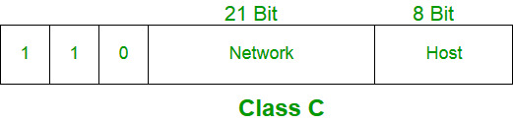

Network ID = 24 bits.

Host ID = 8 bits.

High order bit = 110.

**4)Class D:-**

IP address belonging to class A are reserved for multitasking.

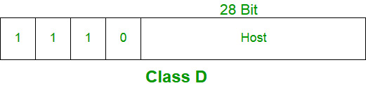

High order bit = 1110.

**5)Class E:-**

IP address belonging to class A are reserved for experimental and research purpose.

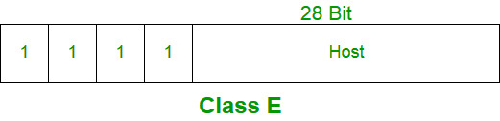

High order bit = 1111.

**10.Network Topologies**

Network Topology is an arrangement with which computer systems or network devices are connected to each other.

There are two types of Topologies:-

**a)Physical Topology:-**

A Physical Topology describes the way in which the computers or nodes are connected with each other in a computer network.

**b)Logical Topology:-**

A logical Topology describes the way, data flows from one computer to another.

There are mainly six types of Network Topology:-

**1)Bus Topology:-**

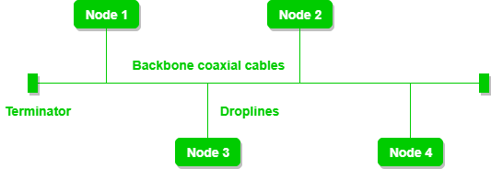

Bus topology is a network type in which every computer and network device is connected to a single cable.

**2)Ring Topology:-**

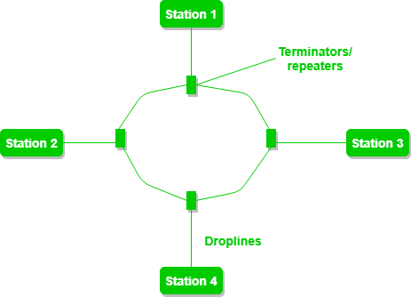

In Ring Topology, each computer is connected to exactly two other computers.

**3)Star Topology:-**

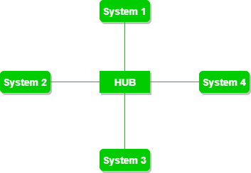

In Star Topology, all the nodes are connected to a centralized hub. In this, Centralized Hub is ‘The Server’ and other peripheral devices are ‘Clients’.

**4)Mesh Topology:-**

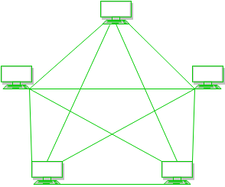

In Mesh Topology, all the nodes are interconnected with each other.

**5)Tree Topology:-**

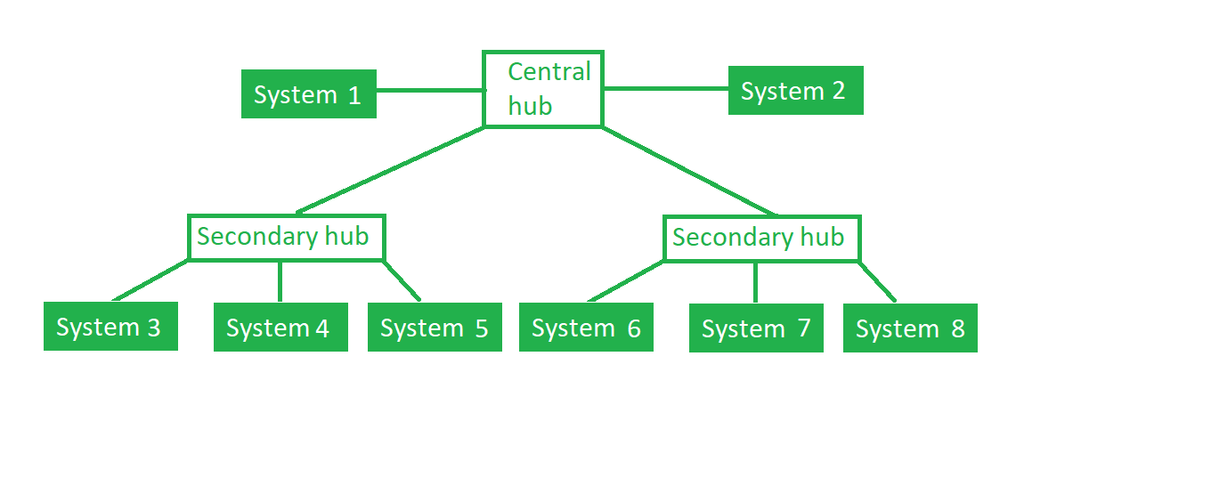

In Tree Topology, all the nodes are directly or indirectly connected to main bus cable. It is the combination of Bus Topology and Star Topology.

**6)Hybrid Topology:-**

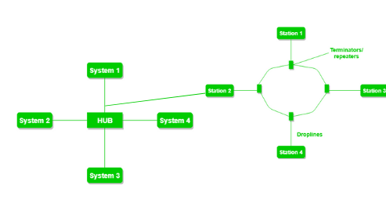

In Hybrid Topology, a computer topology is combination of two or more topologies.

**Report Submission**

**DR. BABASAHEB AMEDKAR TECHNOLOGICAL UNIVERSITY**

**INSTITUTE OF PETROCHEMICAL ENGINEERING**

**Industrial Training Based Learning**

**On**

**HARDWARE AND NETWORKS**

A report submitted to the Department of **INFORMATION TECHNOLOGY**

**Submitted by**

**Roll Number: 2201933**

**PRN Number: 2030408246006**

**Mr. Jadhav Manish Shashikant**

**Course: Industrial Training**

**Submission Date:**

**DEPARTMENT OF INFORMATION TECHNOLOGY ENGINEERING**

**Prof. K. R. Korpe Prof. S. M. Gaikwad**

**Subject In-Charge Head of Department**